

SOFTWARE ENGINEERING II PROJECT

**SafeStreets**

***RASD*** *–* ***R****equirements* ***A****nalysis and* ***S****pecifications* ***D****ocument*

*Professor*:

Matteo G. ROSSI

*Authors*:

Matteo POZZI

Sara SACCO

Andrea VENTURA

November 10, 2019

*version 1.0*

1. Introduction

**1.1 Purpose**

SafeStreets is a mobile application that relies on the help of lawful citizens to make life in the streets less stressful and more organized. The purpose of this document is to describe in depth said application in terms of functional and nonfunctional requirements, so as to help the customer and the developer be on the same page by identifying the former’s needs, and documenting these in a way that makes analysis, communication, and implementation sustainable for both parties.

**1.2 Scope**

The given problem is to create a software system that meets the stakeholders’ needs, which translate with the intent of providing people with the ability to report and notify violations, e.g. vehicles parked in the middle of bike lanes, or in spots reserved to people with disabilities, to the designated authorities.

In particular, citizens should be able to register as users by providing meaningful credentials, so as to avoid wasteful data such as fake accounts, and a way to verify them, e.g. ID or driver license. Once successfully logged in, users should be able to send pictures as proof of vehicles parked illegally and attach additional information to provide authorities with a starting point for the reviewing process, such as the date, the time, the type of violation which is to be reported and the place in which it has occurred, which can be retrieved through the geographical position of the user itself. This means the device which the user is working with should at least be equipped with a camera and a GPS system.

SafeStreets stores the information provided by its users and employs it by running an algorithm on the picture to recognize the license plate number. Such process could be made quicker by the input of the user itself, who is given the option of inserting the license plate information as plain text while filling out their submission. If that were the case, the system should use such information as a starting point for the recognition process, though the algorithm should be run nonetheless as a way of double-checking the information. The stored data can then be elaborated by SafeStreets to highlight the zones which are found to be subject to the highest amount of violations and make them visible to both authorities and citizens.

Furthermore, SafeStreets wants to exploit its own data by combining it with information about accidents and analyzing it in order to identify zones or streets whose safety could be improved by making interventions, possibly suggesting viable solutions as well. This functionality is developed in collaboration with a third party, i.e. the municipality, meaning its usefulness will depend on the possibility of the municipality itself to share its data and match it with the interface SafeStreets developed for the functionality.

Lastly, SafeStreets strives to assist the local police in generating traffic tickets, and possibly build various statistics of interest. To ensure the effectiveness of this service, it is necessary that the exchange of sensible data which must occur between SafeStreets and the municipality cannot be tampered with in any way, e.g. modifying the picture of the violation at hand. To avoid this scenario, SafeStreets should only accept as reliable information pictures that have been taken within the application itself, meaning it should be equipped with an internal camera system.

In the following diagram (Figure 1.1), we define the boundaries of SafeStreets by identifying and distinguishing between World and Machine phenomena, with particular attention to the shared ones.



*Figure 1.1: World and Machine phenomena.*

*1.2.1 Goals*

[**G1**] Allow Citizens to report traffic violations;

[**G2**] Allow Citizens to view a history of their past reports;

[**G3**] Allow Authorities to access stored data about submitted reports and Citizens to view data about accepted ones with limited information;

[**G4**] Allow Authorities to send reports about accidents;

[**G5**] Allow Users to view areas with most violations;

[**G6**] Allow Users to view areas that are marked as unsafe by a System Manager;

[**G7**] Allow the local Authority to generate traffic tickets;

[**G8**] Allow an Authority to link issued traffic tickets to relative Citizens reports;

[**G9**] Allow Users to visualize statistics about issued traffic tickets on violations in a certain area;

[**G10**] Allow System Managers to suggest possible interventions for areas that are deemed unsafe and allow Users to visualize them.

**1.3 Definitions, acronyms, abbreviations**

- Definitions:

**User**: a general actor which is registered into the application; all users can consult statistics about violations and highlight unsafe areas;

**Authority**: a user which receives complaints and is able to identify actual violations among them. It has the power to punish the culprits with traffic tickets;

**Citizen**: a user which is not an authority, he can send reports about violations;

**Violation**: a violation of traffic laws, in particular parking violations;

**Accident**: a traffic event involving two or more vehicles where people got injured or caused damages to the vehicles

**Report**: a notification sent by a citizen to indicate violations, containing all the meaningful information about it;

**Traffic ticket**: a sanction which force an offender of a violation to pay an amount of money, can be generated by authorities;

**Unsafe area**: an area in which many violations and accidents have been reported;

**Statistics**: a collection of data about issued traffic tickets for each kind of violation occurred in a certain area.

**Suggested intervention:** a suggestion made by a system manager to be possibly applied in order to avoid future violations of a certain type.

- Acronyms:

**RASD**: Requirements Analysis and Specifications Document;

**GPS**: Global Positioning System;

**SI**: International System of Units;

**API**: Application Programming Interface.

- Abbreviations:

[**Gn**]: n-th goal;

[**Dn**]: n-th domain property;

[**Rn**]: n-th requirement.

**1.4 Revision history**

**1.5 Reference documents**

**1.6 Document structure**

The document at hand is composed of 6 chapters:

1. Introduction: it includes the goal of the project and an analysis of the world and shared phenomena;
2. Overall description: here we provide further details on the shared phenomena, as well as user characteristics and domain assumptions;
3. Specific requirements: this section provides more details on the aspects presented in Chapter 2;
4. Formal analysis using alloy: it includes a brief presentation of the main objectives of the formal modeling activity, and a description of the model itself;
5. Effort spent: it contains a quantitative description of the effort each member put into the completion of the document;
6. References:

* “Software Abstractions” – Daniel Jackson
* <http://alloytools.org/documentation.html>

1. Overall description
   1. **Product perspective**

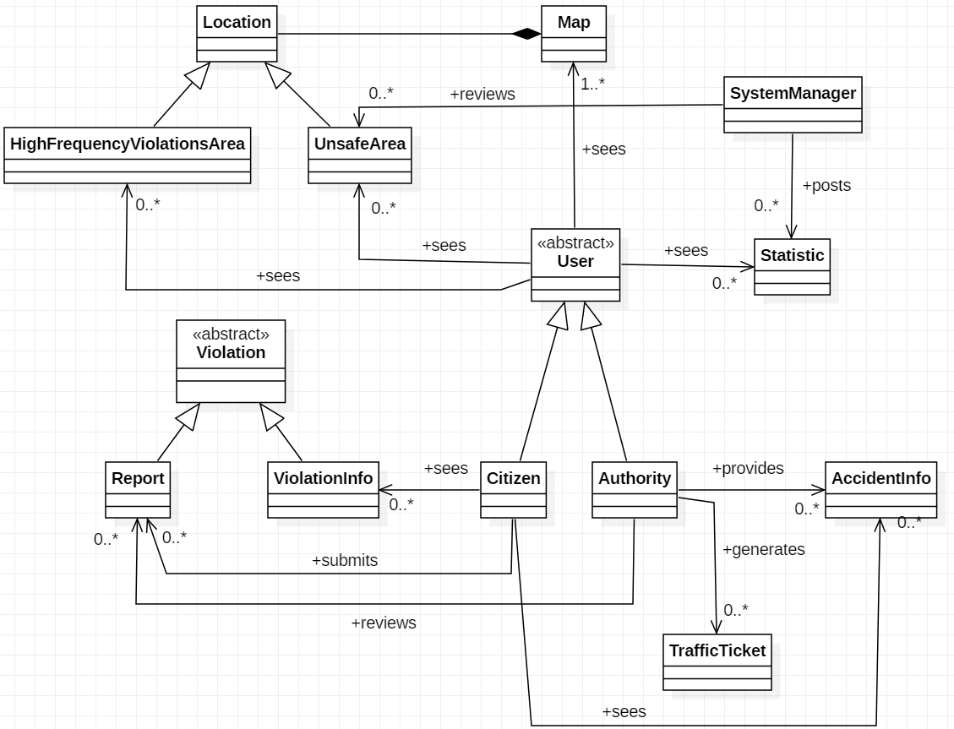

*Figure 2.1: UML class diagram.*

**

*Figure 2.2: State diagram 1: Report filling.*

*Figure 2.3: State diagram 2: Report status.*

* 1. **Product functions**

As previously mentioned, the product offers several functions, which are described more in depth hereunder.

* + 1. *Report management*

This function is the core of the system, as it provides the data needed to carry out the others listed down below. The system allows citizens to take pictures of vehicles committing traffic violations, and asks them to insert relevant information, i.e. position and type of violation, and stores the submitted reports. These can then be evaluated by authorities, who are given the option of accepting or refusing the report at hand as valid.

* + 1. *Ticket generation*

As stated above, this function is built on top of the former, and it is meant for only one of the parties involved in the application, that is the authorities. As a matter of fact, the system will ask users registered as *Authority* whether or not they want to generate traffic tickets concurrently with the acceptance of a submitted report. The process of handling ticket requests is outside of the scope of the application. In particular, the municipality will be in charge of deciding whether or not the ticket actually needs to be issued, how to send it and the amount to pay.

* + 1. *Areas identification*

The function at hand is meant for all end users. In this case, the system will elaborate accepted reports, so as to not consider possibly misleading information such as violations that have not actually occurred, and use them to highlight areas with a high concentration of traffic violations. Users will then be able to exploit such data by viewing the highlighted areas on the system’s map.

* 1. **User characteristics**

The actors interacting with our system are *Citizens* and *Authorities*.

A *Citizen* is a user who has successfully logged into the application using either their mobile phone or a web browser, and is able to access the Internet. They can submit reports via the mobile application, as well as identify areas of interest, or simply observe elaborated data, such as statistics.

An *Authority* is a user who works for the local municipality, and as such receives and reviews submitted reports. They have the power to punish the culprits of traffic violations with traffic tickets.

* 1. **Domain assumptions**

[**D1**] Each User is unique;

[**D2**] Users that register under the Authorities category are employees of the municipality;

[**D3**] A Citizen sends a report about a violation when he notices it;

[**D4**] Information about date and time of the violation corresponds to the date and time when the report is sent;

[**D5**] Information about position is collected through GPS;

[**D6**] Picture of violations are taken at the moment and are not inserted in a second time or from already saved pictures;

[**D7**] Each Citizen reports a certain violation once;

[**D8**] Authorities have tools for assessing if a violation included in a report is an actual violation or not;

[**D9**] Authorities generate traffic tickets only for actual violations;

[**D10**] Authorities are able to find the owner of the vehicle by the license plate, which is unique to each car vehicle;

[**D11**] Authorities report accidents that really occurred;

[**D12**] Authorities report accidents occurred in their territory;

[**D13**] Suggested interventions are always meaningful and reliable and may avoid future violations;

3. Specific requirements

* 1. **User interfaces**

In order to represent the interactions between the system and the customers, we focused on simplicity and tried to design these interfaces ensuring that they are as intuitive as possible. This is a key aspect, as our application is thought to be used also by older people.

* + 1. *Mobile app: Citizens*



*Figure 3.2.*

*Figure 3.1.*

A guest can only perform two actions: sign up, if he hasn’t yet, or sign in (Figure 3.1). In this case, the guest is required to enter their own username and password (Figure 3.2).



*Figure 3.4.*

*Figure 3.3.*

A Citizen who wants to sign up has to insert their own data: first name, last name and fiscal code; then they have to choose an username and a password for their account (Figure 3.3). A registered user can access the menu and in particular they can visit their profile, report a violation, view areas with most violations, view unsafe areas and finally view suggested interventions (Figure 3.4).



*Figure 3.5.*

*Figure 3.6.*

The first picture (Figure 3.5) shows how an user menu should look like. The user can access their own report history and check if their reports have been accepted, rejected or if they haven’t been reviewed yet (Figure 3.6).



*Figure 3.8.*

*Figure 3.7.*

If an user wants to signal a violation, they have to insert the date, the time and choose the type of the violation among those proposed. In addition, it is required to take a photo in which the license plate is clearly visible, and attach the current position (Figure 3.7).

Concerning the areas with most violations, the user is able to visualize them through the map. The areas of interest are also better highlighted, as shown in Figure 3.8.



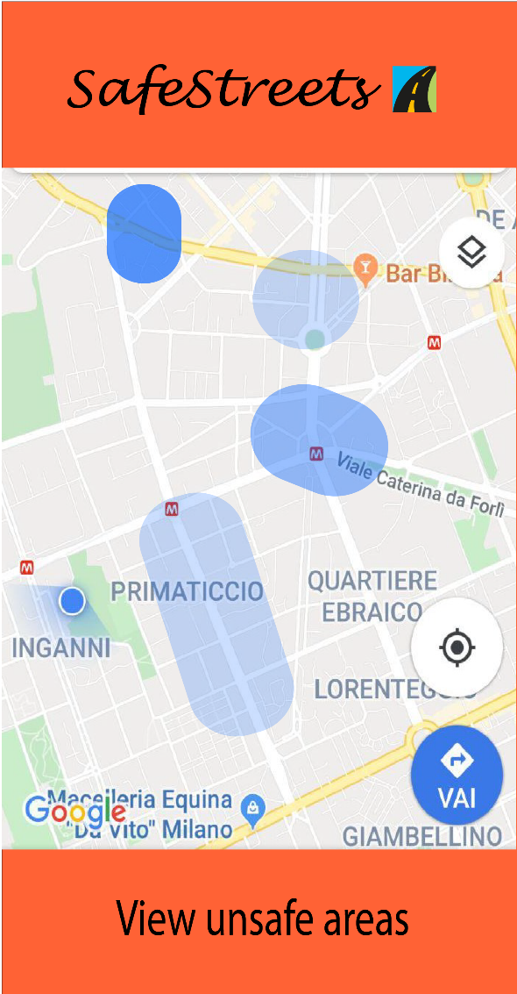

*Figure 3.10.*

*Figure 3.9.*

In the first picture we can observe a pie chart which gives information about violations related to a certain zone (Figure 3.9).

It’s essential to underline that violations in the graph are based on generated tickets and not on all reports made by citizens.

We can also see how areas with most accidents are represented in the map. As explained before, zones with more accidents are highlighted (Figure 3.10).

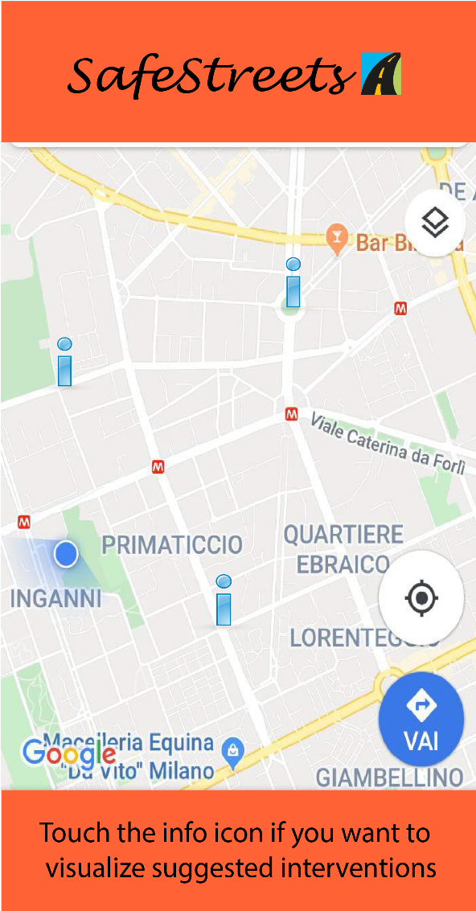

*Figure 3.12.*

*Figure 3.11.*

These interfaces relate to the suggestions made by SafeStreets, crossing its own data with information about accidents. In the map we can see dangerous places which SafeStreets advises to fix (Figure 3.11). The info icon takes the user to a page containing the issue about the involved street and a possible solution (Figure 3.12).

* + 1. *Mobile app: Authorities*

Municipalities who want to sign up have to do it as authority and they have to provide information about their city and their zone; each municipality has a private account that is accessible to authorities who work for the municipality itself. However, big cities which have different municipalities, one for each zone, can have several accounts. Furthermore, authorities have their own personal interfaces, even if they can access the same data available for citizens (such as areas with most violations and statistics). They also have a list of incoming reports and they can generate tickets, reject reports and point out accidents so that SafeStreets is able to build statistics and identify unsafe areas. Some interfaces for authorities are the same as those for citizens: we report the most relevant below.



*Figure 3.14.*

*Figure 3.13.*

Authorities have the list of the violations reported by citizens concerning the area they’re responsible for and they can check if a past report has been reviewed or not (Figure 3.13). Moreover, they can access sensitive information about a violation: after analyzing the report (in particular the photo and the target license), they can refuse or accept it and, consequently, generate a ticket (Figure 3.14).

* + 1. *Web app*

Although the application is thought to be developed for mobiles, we also report an example of web interface, as consulting charts and statistics through a browser could be more comfortable for both citizens and authorities.



*Figure 3.15.*

This is an example of how our web application should show areas with most violations (Figure 3.15).

* 1. **Software interfaces**

The system uses map information taken from external services (e.g. Google Maps API), as well as data provided from a third party, the municipality, and in return sends information about traffic tickets generated directly through the application. The exchange must be thus enabled by an interface through which the municipality and the system can communicate in both directions, in addition to the one handling maps.



*Figure 3.16: Software interfaces.*

* 1. **Functional requirements**



|  |  |
| --- | --- |
| Name | Guest registration |
| Goals | [G1]…[G10] |
| Actors | Guest |
| Entry conditions | The guest has downloaded the application and launched it |
| Events flow | 1. The guest chooses the “sign up” option. 2. The guest selects if he wants to register either as an Authority or a Citizen. 3. The guest fills all mandatory data concerning the chosen category. 4. The guest confirms the operation by selecting the confirmation option. 5. The system saves the data. |
| Exit conditions | The Guest has become an User and can now access the application function offered to the chosen category. The system has saved the data about the User |
| Exceptions | 1. The Guest is already registered into the application. In this case the system invites him to execute the “sign in” operation. 2. One or more of the mandatory fills contain invalid input. In this case the system sends a warning to the Guest and invites him to correct them. |



|  |  |
| --- | --- |
| Name | Sign in |
| Goals | [G1]…[G10] |
| Actors | User |
| Entry conditions | The User is registered to the application and is on the home page. |
| Events flow | 1. The User selects the “sign in” option. 2. The User inserts his credentials into the fields. 3. The User selects the confirmation option. 4. The system redirects the User to his personal home page. |
| Exit conditions | The system recognizes the User as registered and redirects him successfully. |
| Exceptions | 1. The User inserts invalid credentials. In this case the system warns the User and invites him to re-insert them. |

|  |  |
| --- | --- |
| Name | Check areas with most violations |
| Goals | [G5] |
| Actors | User |
| Entry conditions | The User is logged into the system and is on the home page. |
| Events flow | 1. The User selects the “view areas with most violations” option. 2. The system provides the User with a map centered on the User’s current position. 3. The User selects an area onto the map and, eventually, specifies a radius to explore the map in a circumference specified by it. 4. Eventually, the User specifies a filter about violations to look for. 5. The User consults the areas with the most specified violations. |
| Exit conditions | The system has provided the User with all the areas within the desired range from the selected location in which the specified violations have occurred the most. |
| Exceptions | 1. The system couldn’t get the User’s actual position. In this case the system centers the map onto the last visited position and the execution gets to point 3. 2. There are no areas within the specified zone where the filtered violations (or all) occurred. In this case the system shows a message to the User and suggests him to remove some filters or to enlarge the research area. |

|  |  |
| --- | --- |
| Name | Check unsafe areas |
| Goals | [G6] |
| Actors | User |
| Entry conditions | The User is logged into the system and is on the home page. |
| Events flow | 1. The User selects the “view unsafe areas” option. 2. The system provides the User with a map centered on the User’s current position. 3. The User selects an area onto the map and, eventually, specifies a radius to explore the map in a circumference specified by it. 4. The User consults the areas highlighted as unsafe within the specified range. |
| Exit conditions | The system has provided the User with all the areas highlighted as unsafe within the desired range from the selected location. |
| Exceptions | 1. The system couldn’t get the User’s actual position. In this case the system centers the map onto the last visited position and the execution gets to point 3. 2. There are no unsafe areas within the specified zone. In this case the system shows a message to the User and suggests him to enlarge the research area. |

|  |  |
| --- | --- |
| Name | View verified reports |
| Goals | [G3] |
| Actors | User |
| Entry conditions | The User is logged into the system and is on the home page. |
| Events flow | 1. The User selects the “view verified reports” option. 2. The system provides the User with a map centered on the User’s current position. 3. The User selects an area onto the map and, eventually, specifies a radius to explore the map in a circumference specified by it. 4. The system shows a list of all accepted reports coming from the specified area. If the User is a Citizen, the reports will be shown with limited information. 5. The User consults the list of reports. |
| Exit conditions | The system has provided the User with a list of verified reports which have been accepted by an Authority and have occurred within the specified area. |
| Exceptions | 1. The system couldn’t get the User’s actual position. In this case the system centers the map onto the last visited position and the execution gets to point 3. 2. There are no verified reports within the specified zone. In this case the system shows a message to the User and suggests him to enlarge the research area. |

|  |  |
| --- | --- |
| Name | View statistics |
| Goals | [G9] |
| Actors | User |
| Entry conditions | The User is checking the areas with most violations. |
| Events flow | 1. The User selects a location on the map where some violation occurred. 2. The system collects all the violations which took place on the selected location. 3. The system computes statistics about issued traffic tickets for each kind of violation in the area and summarizes them on a chart. 4. The system shows the chart to the User, with a short legend. |
| Exit conditions | The User can consult the chart and infer the type of violations most occurring a certain area. |
| Exceptions | / |

|  |  |
| --- | --- |
| Name | View possible interventions |
| Goals | [G10] |
| Actors | User |
| Entry conditions | The User has just looked for unsafe areas within a certain zone. |
| Events flow | 1. The User consults the list of all unsafe areas found. 2. The User selects one among the unsafe areas. 3. The User selects the “view suggested interventions” option. 4. The User consults all the possible interventions for the unsafe area. |
| Exit conditions | The system has provided the User with a list of all possible interventions for the selected unsafe area. |
| Exceptions | 1. There are no suggested interventions for the selected area. In this case the system shows the User a message to explain this fact. |



|  |  |
| --- | --- |
| Name | Issue report |
| Goals | [G1] |
| Actors | Citizen |
| Entry conditions | The Citizen has spotted a possible violation and wants to report it. |
| Events flow | 1. The Citizen selects the “report a violation” option. 2. The Citizen selects the type of violation from a list containing the reportable ones. 3. The Citizen selects the “take a photo” option. 4. The Citizen takes a photo of the involved vehicle making sure that the license plate is visible and readable. 5. The system analyzes the photo. 6. The system accepts the photo and takes the Citizen back to the report form. 7. The Citizen selects the “send your position” option. 8. The system collects the actual position of the Citizen. 9. The Citizen confirms the operation by selecting the relative option. 10. The system receives the data and saves them. |
| Exit conditions | The system has received the incoming data correctly and managed to store them. |
| Exceptions | 1. The system couldn’t recognize or read the license plate from the photo. In this case the system warns the Citizen about the issue and asks him to take the photo again. 2. The system couldn’t retrieve the Citizen’s current position. In this case, the system warns the Citizen about the issue and asks him to activate his GPS. 3. The system didn’t receive the data about the report. In this case the system shows the Citizen an error message and asks him to redo the whole operation. |

|  |  |
| --- | --- |
| Name | View past reports |
| Goals | [G2] |
| Actors | Citizen |
| Entry conditions | The Citizen is logged into the system and is on the home page. |
| Events flow | 1. The Citizen selects the “my profile” option. 2. The system redirects the Citizen to his personal profile. 3. The Citizen selects the “my reports” option. 4. Eventually, the Citizen enters a time filter to exclude too “old” reports. 5. The Citizen consults a list of his submitted reports in the desired time period. |
| Exit conditions | The system has shown a list of the Citizen’s past reports submitted in a time such that the filter is satisfied, including a description of the report’s status. |
| Exceptions | 1. The Citizen never submitted a report. 2. There are no reports that satisfy the inserted filter.   In both cases, the system shows a message to the Citizen describing the issue. |



|  |  |
| --- | --- |
| Name | Evaluate submitted report |
| Goals | [G3] |
| Actors | Authority |
| Entry conditions | The Authority is logged into the system and is on the home page. |
| Events flow | 1. The Authority selects the “check submitted reports” option. 2. The system provides the Authority with a list of all not already evaluated reports from its areas of competence, with a brief description. 3. The Authority selects a report among the list. 4. The system expands the selected report including all its data. 5. The Authority checks the data of the selected report. 6. The Authority evaluates the report as accepted or rejected. 7. The system saves the new status of the report. |
| Exit conditions | The report’s new status is either accepted or rejected and the system saves the status according to the Authority’s decision. |
| Exceptions | 1. All the reports of competence of the Authority have already been evaluated. In this case the system shows the Authority a message explaining the issue. 2. The Authority doesn’t choose between accepting or rejecting the report. In this case the system warns the Authority and asks him to choose between interrupting the process or complete it. If the process is interrupted the report maintains its precedent status, else the process resumes from where it was suspended. |

|  |  |
| --- | --- |
| Name | Generate traffic ticket |
| Goals | [G7] [G8] |
| Actors | Authority |
| Entry conditions | The Authority has just evaluated a report as accepted. |
| Events flow | 1. The system asks the Authority if he wants to generate a traffic ticket from the evaluated report. 2. The Authority takes a decision on this. If it accepts, then the process continues to step 3, else it is terminated. 3. The system asks the Authority the amount of money to include in the traffic ticket. 4. The Authority inserts the amount of money. 5. The Authority confirms the operation. 6. The system emits the traffic ticket and it associates it to the license plate of the vehicle which committed the violation. 7. The system associates the emitted traffic ticket to the evaluated report. |
| Exit conditions | If the traffic ticket isn’t emitted, the report is saved just as accepted.  If the traffic ticket is emitted, it is sent to the owner of the vehicle found by license plate, the system saves the new status of the report with the issued traffic ticket. |
| Exceptions | 1. The Authority inserts an invalid amount of money (negative or too high). In this case the system warns the Authority and asks him to insert a valid value. |

|  |  |
| --- | --- |
| Name | Report accident |
| Goals | [G4] |
| Actors | Authority |
| Entry conditions | The Authority has all the information about an accident occurred in its area of competence. |
| Events flow | 1. The Authority selects the “report accident” option. 2. The Authority inserts the data about date and time when the accident occurred. 3. The Authority inserts the data about the location where the accident occurred. 4. The Authority inserts the data about the type and how many vehicles were involved in the accident. 5. The Authority inserts the data about how many people were injured in the accident. 6. The Authority inserts data about if any emergency vehicle was dispatched and if it was able to reach the place in good time. 7. The Authority inserts a brief description including any other relevant data in order to fully describe the accident. 8. The Authority confirms the operation and send the report. 9. The system receives the data about the report and saves them. |
| Exit conditions | The system has received the report and managed to store the data. |
| Exceptions | 1. The Authority inserts an invalid input in any of the fields (most likely the date). In this case the system warns the Authority and asks him to correct the input. |



|  |  |
| --- | --- |
| Name | System Manager sign in |
| Goals | [G6] [G10] |
| Actors | System Manager |
| Entry conditions | / |
| Events flow | 1. The System Manager opens the application from his private interface. 2. The System Manager enters his credentials. 3. The System Manager selects the confirmation option. 4. The system redirects the System Manager to the maintenance area. |
| Exit conditions | The System Manager is logged into the system and can perform maintenance operations. |
| Exceptions | 1. The System Manager inserts wrong credentials. In this case the system warns the System Manager and invites him to insert the correct ones. |

|  |  |
| --- | --- |
| Name | Report unsafe area |
| Goals | [G6] |
| Actors | System Manager |
| Entry conditions | The System Manager has noticed a dangerous area because of many accepted violations and/or accidents and he is logged into the system. |
| Events flow | 1. The System Manager selects the “areas management” option. 2. The System Manager searches the area he wants to highlight. 3. The System Manager selects the area. 4. The System Manager marks the area as “unsafe”. 5. The System Manager confirms the modification. 6. The system saves the new status of the area. |
| Exit conditions | The system has successfully saved the modification. |
| Exceptions | / |

|  |  |
| --- | --- |
| Name | Suggest intervention |
| Goals | [G10] |
| Actors | System Manager |
| Entry conditions | The System Manager has noticed the same violation or accident occurring several times in a certain area and he is logged into the system. |
| Events flow | 1. The System Manager selects the “area management” option. 2. The System Manager searches the area he wants to revise. 3. The System Manager selects the area. 4. The System Manager selects the “suggest intervention” option. 5. The System Manager fills with a brief description the possible intervention to prevent other violations to occur. 6. The System Manager confirms the modification. 7. The system saves the suggestion description in the area. |
| Exit conditions | The system has successfully saved the modification. |
| Exceptions | / |

[**G1**] **Allow Citizens to report traffic violations;**

[R1] The system must be able to distinguish between logged users and guests;

[R2] The system must require information input by the user, such as type of violation, during the filling out process;

[R3] The system must inform the user whether their report has been stored successfully or not;

[R4] The system must ask users if they want to retry the submission process using the same data that failed being sent, or if they want to cancel it;

[D1] Each User is unique;

[*D3*] A Citizen sends a report about a violation when he notices it;

[D4] Information about date and time of the violation corresponds to the date and time when the report is sent;

[D5] Information about position is collected through GPS;

[D6] Picture of violations are taken at the moment and are not inserted in a second time or from already saved pictures;

[D7] Each Citizen reports a certain violation once;

[**G2**] **Allow Citizens to view a history of their past reports;**

[R5] The system must be able to distinguish every user unambiguously;

[R6] The system must store information with an association to the user who submitted it;

[R7] The system must be able to retrieve stored information;

[R8] The system must allow reports to have only one status at a time (accepted, rejected, to be checked);

[R9] The system must tell the user whether their report has been accepted, rejected or is still waiting to be checked;

[D1] Each User is unique;

[**G3**] **Allow Authorities to access stored data about submitted reports and Citizens to view data about accepted ones;**

[R7] The system must be able to retrieve stored information;

[R10] The system must be able to distinguish between authorities and users;

[R11] The system must be able to distinguish between submitted reports and reports that have been reviewed and accepted by the police;

[R12] The system must anonymize data shown to regular users (citizens), that is hide information about the vehicles that were parked illegally and about who submitted a particular report; in other words, data about reports that is shown to users must only contain the type of violation, date, time and position;

[R13] The system must show the full data about a report to authorities;

[D1] Each User is unique;

[D2] Users that register under the Authorities category are employees of the municipality;

[D8] Authorities have tools for assessing if a violation included in a report is an actual violation or not;

[**G4**] **Allow Authorities to send reports about accidents;**

[R10] The system must be able to distinguish between authorities and users;

[R14] An authority must be able to submit reports about accidents;

[D2] Users that register under the Authorities category are employees of the municipality;

[D11] Authorities report accidents that really occurred;

[D12] Authorities report accidents occurred in their territory;

[**G5**] **Allow Users to view areas with most violations;**

[R7] The system must be able to retrieve stored information;

[R12] The system must be able to anonymize data shown to regular users (citizens), that is hide information about the vehicles that were parked illegally and about who submitted a particular report; in other words, data about reports that is shown to users must only contain the type of violation, date, time and position;

[R13] The system must show the full data about a report to authorities;

[R15] The system must be able to access map information;

[R16] The system must show the user their local map information;

[D5] Information about position is collected through GPS;

[**G6**] **Allow Users to view areas that are marked as unsafe by a System Manager;**

[R15] The system must be able to access map information;

[R16] The system must show the user their local map information;

[R17] The system must show the user possible solutions for unsafe areas, if there are any;

[R18] The system must allow system managers to edit the status of an area as unsafe and the other way around;

[D5] Information about position is collected through GPS;

[**G7**] **Allow the local Authority to generate traffic tickets *from accepted reports*;**

[R8] The system must allow reports to have only one status at a time (accepted, rejected, to be checked);

[R13] The system must show the full data about a report to authorities;

[R19] An authority must be able to generate a traffic ticket from a report;

[R20] The system must offer the possibility to generate a traffic ticket only to reports which has the status of accepted;

[D2] Users that register under the Authorities category are employees of the municipality;

[D9] Authorities generate traffic tickets only for actual violations;

[D10] Authorities are able to find the owner of the vehicle by the license plate, which is unique to each car vehicle;

[**G8**] **Allow an Authority to link issued traffic tickets to relative Citizens reports;**

[R5] The system must be able to distinguish every user unambiguously;

[R7] The system must be able to retrieve stored information;

[R19] An authority must be able to generate a traffic ticket from a report;

[R20] The system must offer the possibility to generate a traffic ticket only to reports which has the status of accepted;

[R21] The system must allow Authorities to know which Citizen sent each report;

[D1] Each User is unique;

[D2] Users that register under the Authorities category are employees of the municipality;

[D7] Each Citizen reports a certain violation once;

[**G9**] **Allow Users to visualize statistics about issued traffic tickets on violations in a certain area;**

[R7] The system must be able to retrieve stored information;

[R15] The system must be able to access map information;

[R16] The system must show the user their local map information;

[R22] The system must be able to compute meaningful statistics on reports about each kind of violation in which a traffic ticket has been generated;

[R23] The system must make data about statistics visible to all users;

[**G10] Allow System Managers to suggest possible interventions for areas that are deemed unsafe and allow Users to visualize them.**

[R7] The system must be able to retrieve stored information;

[R15] The system must be able to access map information;

[R16] The system must show the user their local map information;

[R24] The system must allow system managers to suggest interventions for unsafe areas;

[R25] The system must show the user possible solutions for unsafe areas, if there are any;

[R26] The system must make data about suggested interventions visible to all users;

[D13] Suggested interventions are always meaningful and reliable and may avoid future violations;

* 1. **Performance requirements**

The system should notify the user whether their submission has been submitted properly, that is, it has been received and stored without corruption of data, within one minute after the moment it has been sent.

* 1. **Design constraints**

*3.5.1 Standards compliance*

The system adopts units of measure that are compliant with the SI. In particular, distance is expressed in terms of meters [*m*].

* + 1. *Hardware limitations*

As stated previously, the SafeStreets mobile application requires that the device being used can:

* access the Internet through a secure and stable connection;
* provide its own position through GPS;
* take pictures, meaning it has to be equipped with a camera.
  1. **Software system attributes**
     1. *Availability*

The system must have an availability of 99,9%, meaning at most 8.76 hours/year of downtime.

* + 1. *Security*

The system must encrypt sensitive information about users and make sure it is protected during the exchange of data; furthermore, it is necessary that personal information can only be released in case the request to see it was sent by authorities.

* + 1. *Portability*

Users must be able to access the service through mobile platforms, in particular the most common ones, e.g. iOS, Android, but some functionalities, such as viewing the system’s map or the statistics released by the system itself, can be accessed also via web browser.